**Zainab Shahzad**

**SAP ID 56108**

**LAB 08**

**TASK 1:**

.model small

.stack 100h

.data

.code

main proc

mov cx,26

mov dx,97

PrintDigit:

mov ah,2

int 21h

inc dx

Loop PrintDigit

mov ah,4ch

int 21h

main endp

endp main

**OUTPUT:**

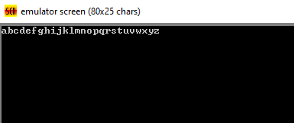

**TASK 2:**

.model small

.stack 100h

.data

.code

msg DB "Enter a character:$"

main proc

mov ax,@data

mov ds,ax

mov dl,msg

mov dx,offset msg

mov ah,9

int 21h

mov ah,1

int 21h

mov bx,ax

mov cx,10

mov dl,10

mov ah,2

int 21h

mov dl,13

mov ah,2

int 21h

mov dx,bx

PrintDigit:

mov ah,2

int 21h

Loop PrintDigit:

mov ah,4ch

int 21h

main endp

end main

**Output:**

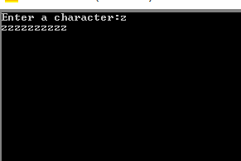

**Task 4:**

.model small

.stack 100h

.data

result db 0

.code

main proc

mov cx,3

mov ax,0

AddNumbers:

add ax,cx

loop AddNumbers

mov result,al

mov ah,2

mov dl,result

mov dl,48

int 21h

mov ah,4ch

int 21h

main endp

end main

**Output:**

